**Game of Connect Four**

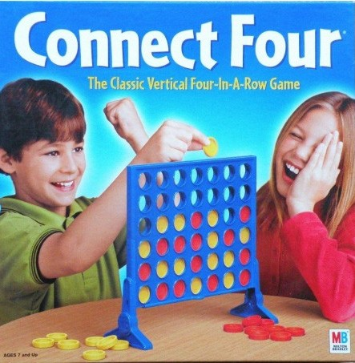

https://lauamangud.ee/3979-large_default/connect-four-travel-edition.jpg

[Wikipedia] ***Connect Four*** *is a two‐player connection game in which the players first choose a color and then take turns dropping one colored disc from the top into a seven‐column, six‐row vertically suspended grid. The pieces fall straight down, occupying the lowest available space within the column. The objective of the game is to be the first to form a horizontal, vertical, or diagonal line of four of one's own discs.* You can refer to the following animation of gameplay example provided by Wikipedia: https://en.wikipedia.org/wiki/Connect_Four#/media/File:Connect_Four.gif

You can also play the online Connect Four game: ht[tps://w](http://www.mathsisfun.com/games/connect4.html)ww.mat[hsisfun.com/games/connect4.html](http://www.mathsisfun.com/games/connect4.html)

Below we list the game rules of Connect Four:

1. There are two players with symbols “X” and “O”.
2. The board game is a 6×7 two-dimensional grid where playing discs may be placed.
3. The board game starts out empty.
4. Player “X” plays first. Then play will alternate between the two players one round at a time.
5. A playing disc is placed on the board by choosing a column into which to “drop” the disc. The disc starts in the highest row and then then “falls” down to the lowest point available in that column.
6. A column may become full and then no more playing discs may be dropped into that column.
7. If all of the points on the board fill up without any player winning, then the game ends in a draw.

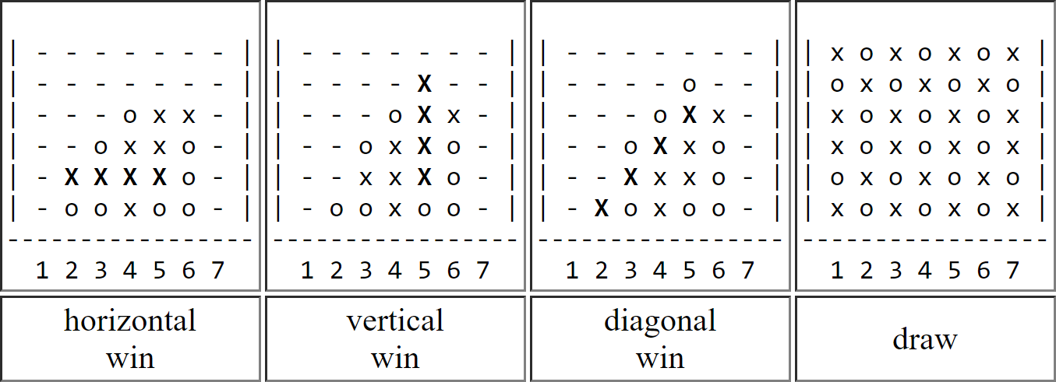Here are the four possible end game examples.

Besides the rules of Connect Four, you program is also required to do the following items.

1. Examine whether the column is full. If full, show “This column is full. Try another column.”
2. Examine whether the user input number is in the correct range (0-6), If not in the correct range, show “Out of range, try again [0-6].”
3. Examine whether the user input is valid (only numbers are valid). If the input is not valid, show “Invalid input, try again [0-6].”
4. If someone wins the game, show the lowercase symbol (“o” or “x”) for all connected 4 discs. If more than 4 connected discs or more than two connected lines, lowercase all of them.

**Sample Input/Output:**

Start of the game.

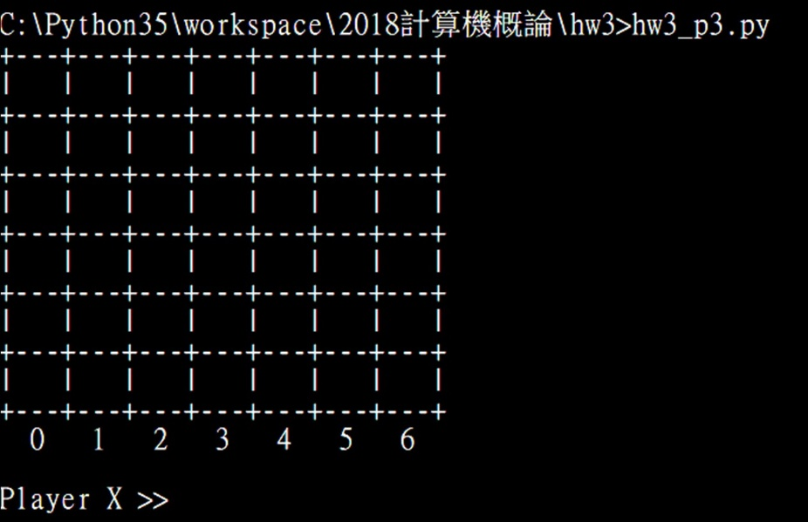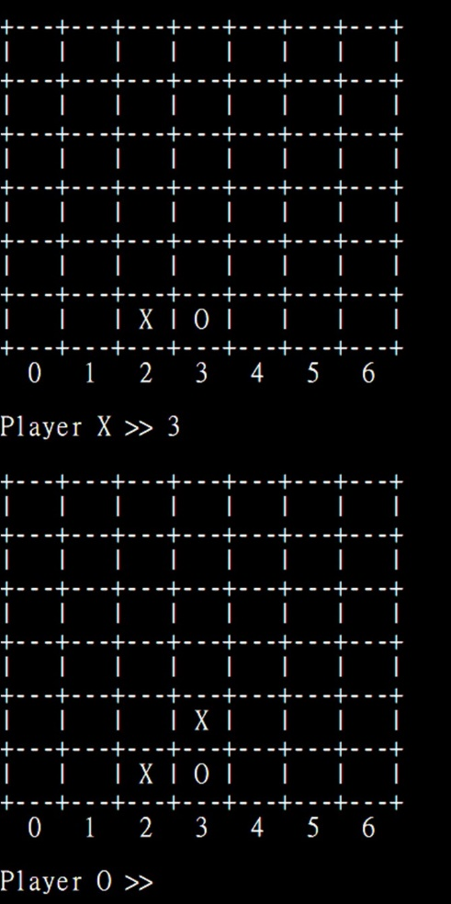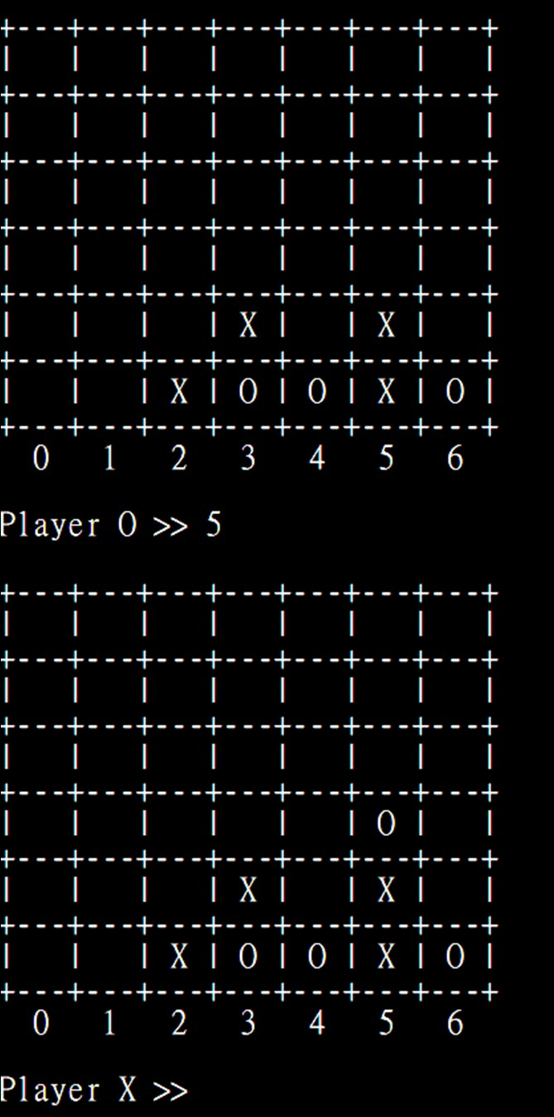

Allow each player to enter the column and show the updated table.

If invalid inputs or out of range, ask the user to input again.

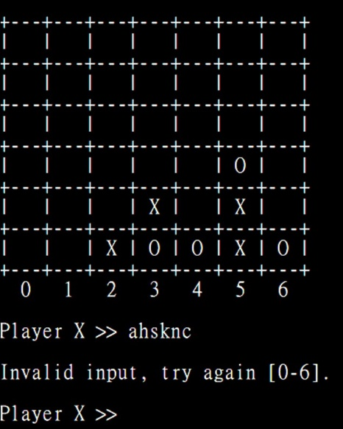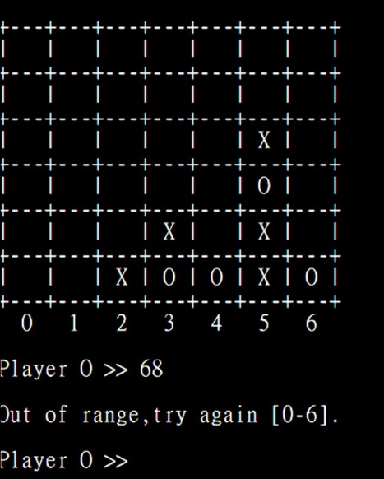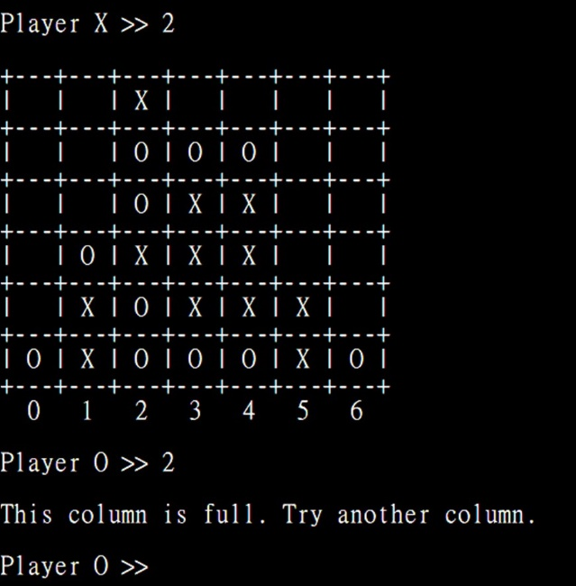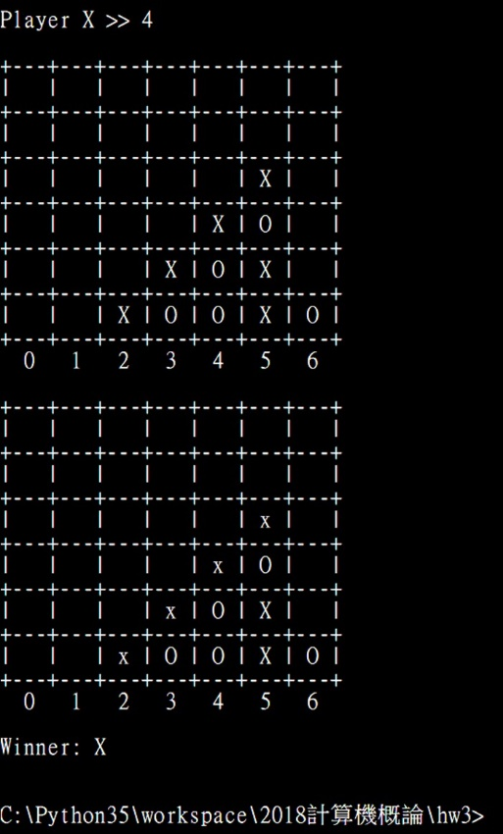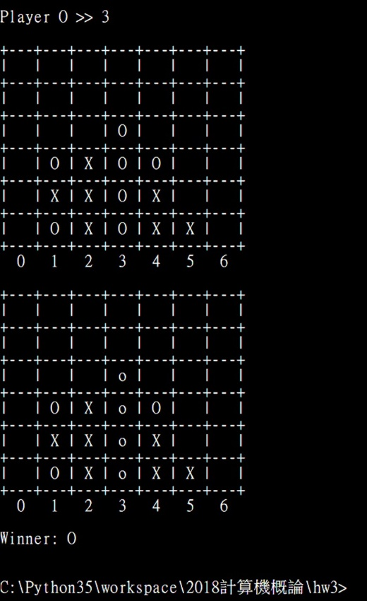

If the column is full, ask the user to input again.

If 4 discs are connected, need to lowercase them. (Here are two examples: diagonal and vertically connected)

